**CHAPTER-4 Class Room Objective**

**ANALYTICAL REASONING**

The chapter on Analytical reasoning involves the problems relating to the counting of geometrical figures in a given complex figure. The systematic method for determining the number of any particular type of figure by the analysis of the complex figure would be clear from the examples that follow.

**Ex1.** The maximum number of squares in the figure is

|  |  |  |
| --- | --- | --- |
|  |  |  |
|  |  |  |
|  |  |  |

a) 9 b) 10 c) 13 d) **14**

**Ex2.** The maximum number of squares in the figure is

|  |  |  |  |
| --- | --- | --- | --- |
|  |  |  |  |
|  |  |  |  |
|  |  |  |  |
|  |  |  |  |

a) 16 b) 17 c) 26 d) **30**

**Ex3.**The maximum number of squares in the figure is

|  |  |  |  |  |  |
| --- | --- | --- | --- | --- | --- |
|  |  |  |  |  |  |
|  |  |  |  |  |  |
|  |  |  |  |  |  |
|  |  |  |  |  |  |
|  |  |  |  |  |  |
|  |  |  |  |  |  |

a) 85 b) **91** c) 105 d) 112

**Ex4.** The number of triangles in the following diagram is:

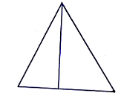

a) **2**  b) 3 c) 4 d) 5

**Ex5.** The number of triangles in the following diagram is:

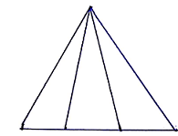

a) **6**  b) 7 c) 8 d) 10

**Ex6.** The number of triangles in the following diagram is:

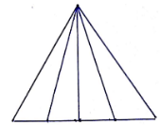

a) 6 b) 7 c) 8 d) **10**

**Ex7.** The number of triangles in the following diagram is:

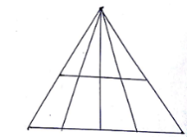

a) **20** b) 21 c) 22 d) 23

**Ex8.** The number of triangles in the following diagram is:

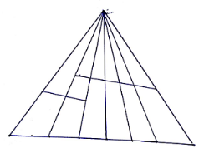

a) 38 b) **39** c) 40 d) 41

**Ex9.** The number of triangles in the following diagram is

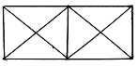

a) **18** b) 19 c) 20 d) 21

**Ex10.** The number of triangles in the following diagram is

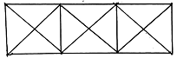

a) **28** b) 29 c) 30 d) 31

**Ex11.** The number of triangles in the following diagram is

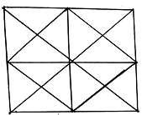

a) 40 b) 42 c) **44** d) 46

**Ex12.** The number of triangles in the following diagram is

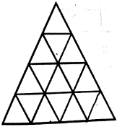

a) **27** b) 28 c) 29 d) 30

**Ex13.** The number of triangles in the following diagram is

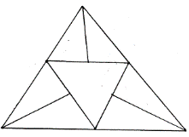

a) 9 b) 10 c) **11** d) 12

**Ex14.** The number of triangles in the following diagram is

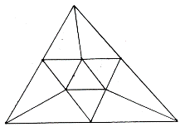

a) **15** b) 16 c) 17 d) 18

**Ex14.** The number of triangles in the following diagram is

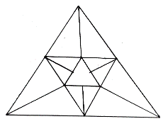

a) 20 b) **21**  c) 22 d) 23

**Ex15.** The number of triangles in the following diagram is

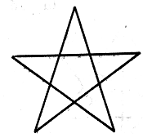

a) 5 b) 6 c) 8 d) **10**

|  |
| --- |
| **EXCERCISE** |

**Q1.** The number of triangles in the following diagram is

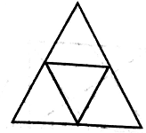

a) 4 b) 5 c) 6 d) 7

**Q2.** The number of triangles in the following diagram is

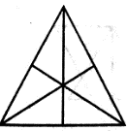

a) 16 b) 13 c) 9 d) 7

**Q3.** The number of triangles in the following diagram is

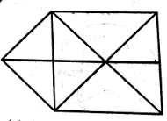

a) 15 b) 16 c) 17 d) 18

**Q4.** The number of triangles in the following diagram is

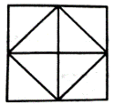

a) 8 b) 10 c) 12 d) 14

**Q5**. The number of triangles in the following diagram is

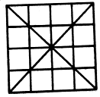

a) 36 b) 40 c) 44 d) 48

**Q6**. The number of triangles in the following diagram is

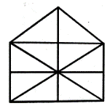

a) 10 b) 19 c) 21 d) 23

**Q7.** The number of circles in the following diagram is

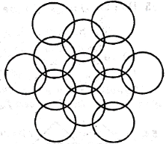

a) 11 b) 12 c) 13 d) 14

**Q8.** The number of circles in the following diagram is

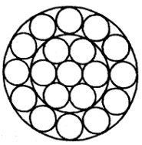

a) 19 b) 18 c) 17 d) 21

**Q9**. The number of circles in the following diagram is

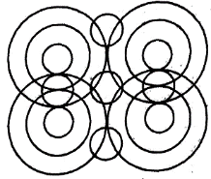

a) 14 b) 16 c) 17 d) 18

**Q10.** The number of circles in the following diagram is

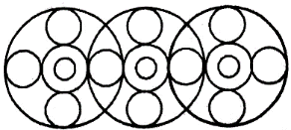

a) 18 b) 19 c) 16 d) 20

*************************